# 1 Ethics

讨论考试权重和practice problem是可以的，只要不是confidential information即可

CFA题目：不透露真题即可

compliance policies and procedures需要一直更新，要Periodic review，只有initial review是不够的

Referral Fees requires Members and Candidates to disclose to their employer, clients, and prospective clients, as appropriate, any compensation, consideration, or benefit received from or paid to others for the recommendation of products or services **before entry into any formal agreement for services**.

在签约前必须要先披露利益冲突

CFA Title: 和厉害不厉害没关系

**Statements overstating the competency of an individual or imply, either directly or indirectly, that superior performance can be expected from someone with the CFA designation are not allowed under Standard VII (B) Reference to CFA Institute, the CFA Designation, and the CFA Program**.

说一次就考过是可以的

**It is not a violation, however, to factually state that charter holders must annually renew their commitment to abide by the Code and Standards or that each of the team members passed all three CFA exams on their first attempt.**

Standard III (B): Fair Dealing accommodates the differentiation of services to clients as long as such services are not offered selectively. The different service levels should be disclosed to clients and prospective clients and should be available to everyone.

内部消息

Standard II (A): Material Nonpublic Information **does not disallow the possession of insider information but does disallow using the information to take unfair advantage of the general investing public**.

按照客户要求投资（不一定都要diversify）

Standard III (A): Loyalty, Prudence, and Care require a client's portfolio to be managed by investment guidelines agreed on with the client. **Some clients' investment objectives may not allow for a diversified portfolio across all asset classes available.**

Standard IV(C): **Responsibilities of Supervisors requires supervisors to enforce non-investment-related policies as well as investment-related policies.**

# 2 Quantitative Methods

## 2.1 Regression

|  |  |  |  |
| --- | --- | --- | --- |
| Assumption Violation | Impact | Detection | Solution |
| Heteroskedasticity | Incorrect Standard Errors | Residual scatter plots Breusch-Pagen $χ^{2}$-test  ($BP=n×R_{residual}^{2}$) | Robust Standard Errors;  GLS |
| Serial Correlation | Incorrect Standard Errors | Residual Scatter Plots;  Durbin-Watson Test | Hansen Method |
| Multicollinearity | High $R^{2}$ and low t-statistics | t-tests: fail to reject $H_{0}$;  F-test: reject $H_{0}$/ high $R^{2}$ High magnitude of pairwise  correlations | Remove one or more independent variables |

## 2.2 Time Series

$$AR\left(1\right): X_{t} =b_{0} +b_{1}X_{t-1} +ε_{t}$$

$$Mean Reverting Level of AR\left(1\right)=\frac{b_{0}}{1-b_{1}}$$

$${AR\left(p\right): X}_{t}=b_{0}+b_{1}X_{t-1}+b_{2}X_{t-2} +⋯+b_{p}X_{t-p}+ε_{t}$$

**Covariance stationary**: mean and variance don't change over time. To determine if a time series is covariance stationary, (1) plot data; (2) run an AR model and test correlations; (3) perform Dickey Fuller test.

Unit root: coefficient on lagged dep. vbl. = 1. Series with unit root is not covariance stationary. First differencing will often eliminate the unit root.

Autoregressive (AR) model: specified correctly if aurocorrelation of residuals not significant.

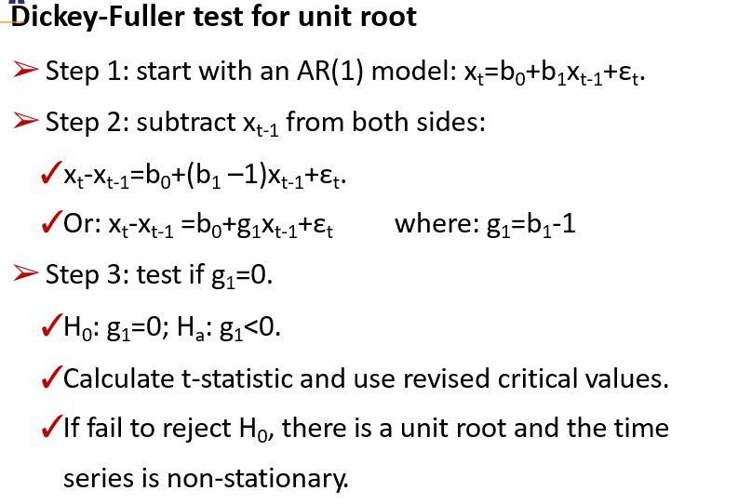**Dickey-Fuller test for unit root**

* + - * + **The unit root test of nonstationarity**

Start with an AR(1) model

$$AR\left(1\right): X_{t}=b_{0}+b_{1}X_{t-1}+ε_{t}$$

Subtract $X_{t-1}$ from both sides

$$X_{t}-X_{t-1}=b_{0}+\left(b_{1}-1\right)x_{t-1}+ε_{t}=b_{0}+gx_{t-1}+ε_{t}$$

$$H_{0}: g=0$$

$$H_{a}: g<0$$

Calculate conventional t-statistic and use revised t-table

If we can reject the null, the time series does not have a unit root and is stationary

**Autoregressive Conditional Heteroskedasticity (ARCH)**

$$ARCH\left(1\right): ε_{t}^{2} =a_{0} +a_{1}ε_{t-1}^{2}+μ_{t}$$

* **GLS must be used to develop a predictive model**

## 2.3 Machine Learning

**Performance Evaluation**

$$Precision=\frac{TP}{TP+FP}$$

$$Recall=\frac{TP}{TP+FN}$$

$$Accuracy =\frac{TP+TN}{TP+FP+TN+FN}$$

$$F_{1} Score=\frac{2PR}{P+R}$$

False Positive 和 False Negative 含义记忆法

False Positive : False(检测模型不能成功地) Positive (判定出结果是Positive的) type I error

False Negative : False(检测模型不能成功地) Negative (判定出结果是Negative的) type II errors

True Positive : True(检测模型成功地) Positive (判定出结果是Positive的)

True Negative : True(检测模型成功地) Negative (判定出结果是Negative的)

具体例子:

病者癌症为良性，检测结果为恶性，则为False Positive，假阳性

病者癌症为良性，检测结果为良性，则为True Positive，真阳性

病者癌症为恶性，检测结果为恶性，则为True Negative，真阴性

病者癌症为恶性，检测结果为良性，则为False Negative，假阴性

对错+结果

Precision是针对预测结果而言的，它表示的是预测为正的样本中有多少是真正的正样本。

Recall是针对原来的样本而言的，它表示的是样本中的正例有多少被预测正确了。

The F1 score is the harmonic mean of the precision and recall. The highest possible value of an F-score is 1.0, indicating perfect precision and recall, and the lowest possible value is 0, if either the precision or the recall is zero.

Kotak wants to minimize false positives (i.e., classifying companies that are not takeover targets as takeover targets), and hence, wants to minimize type I errors. An increase in a model's precision reduces its type I errors. A model's accuracy score generally minimizes overall type I and type II errors, and hence, is not the best answer choice.

**Receiver Operating Characteristic (ROC)**: This technique for assessing model performance involves the plot of a curve showing the trade-off between the false positive rate (x-axis) and true positive rate (y-axis) for various cutoff points.

**Root mean square error (RMSE)**: The RMSE is a single metric summarizing the prediction error in a sample.

$$RMSE=\sqrt{\frac{\sum_{i=1}^{n}{{\left(predicted_{i}-actual_{i}\right)}^{2}}}{n}}$$

# 3 Economics

## 3.1 Foreign Exchange

**Cross Rate**

* **相乘同边，相除对角，乘小除大。**
* **Bid和Ask是Market Maker的角度。做市商的买入价是Bid, 做市商的卖出价是Ask**

$${\left(\frac{A}{C}\right)}_{bid}={\left(\frac{A}{B}\right)}_{bid}∙{\left(\frac{B}{C}\right)}_{bid}$$

$${\left(\frac{A}{C}\right)}_{offer}={\left(\frac{A}{B}\right)}_{offer}∙{\left(\frac{B}{C}\right)}_{offer}$$

$${\left(\frac{GBP}{USD}\right)}_{bid}=\frac{1}{{\left(\frac{USD}{GBP}\right)}_{offer}}$$

**Forward Premium**

$$Forward Premium=Forward Price-Spot Price$$

$$F-S=S\left[\frac{\frac{days}{360}}{1+r_{B}\frac{days}{360}}\right](r_{A}-r_{B})$$

$$\overset{⇔}{ }F\left[1+r_{B}\frac{days}{360}\right]=S\left[1+r_{A}\frac{days}{360}\right]$$

$$\overset{⇔}{ }F=S\frac{1+r_{A}\frac{days}{360}}{1+r_{B}\frac{days}{360}}$$

**Mark-to-market Value Prior to Expiration**

$$V_{t}=\frac{\left(FP_{t}-FP\right)\left(contract size\right)}{1+R\frac{days}{360}}$$

## 3.2 Interest Rate Parity

**Covered Interest Rate Parity**

$$F=S\frac{1+r_{A}\frac{days}{360}}{1+r_{B}\frac{days}{360}}$$

* **An investment in a foreign money market instrument that is completely hedged against exchange rate risk yields exactly the same return as an otherwise identical domestic money market investment.**
* **The currency with higher nominal yield will depreciate.**

**Uncovered Interest Rate Parity**

$$\left(1+r_{A}\right)\left(1-E{\left(\%ΔS\right)}_{A|B}\right)=1+r_{B}$$

$$E{\left(\%ΔS\right)}_{\left(A | B\right)}≈r_{A}-r_{B}$$

* **The change in spot rate over the investment horizon should, on average, equal the differential in interest rate between the two countries.**
* **The expected appreciation/depreciation of the exchange rate just offsets the yield differential, implying that the current forward exchange rate is an unbiased predictor of the future spot rate.**
* **Uncovered interest rate parity assumes that there are enough risk-neutral investors to force equality of expected returns.**
* **When uncovered interest rate parity does not hold, in a FX carry trade, an investor invests in a higher yielding currency using funds borrowed in a lower yielding currency.**
* **During periods of low volatility, carry trades tend to generate positive returns, but they are prone to significant crash risk in turbulent times.**
* **Forward rate parity: The forward exchange rate will be an unbiased predictor of the future spot exchange rate if both covered and uncovered interest rate parity hold.**
* **Covered interest rate parity derives the no-arbitrage forward rate, while uncovered interest rate parity derives the expected future spot rate.**
* **Covered interest parity is assumed by arbitrage.**
* **Uncovered interest parity does not hold in the short run, and it dose hold in the long run. So longer-term expected future spot rates based on uncovered interest rate parity are often used as forecasts of future exchange rates.**

**Purchasing Power Parity**

* **Absolute Purchasing Power Parity: the equilibrium exchange rate between two countries is determined entirely by the ratio of their national price levels.**
$$S_{A|B}=\frac{P_{A}}{P_{B}}$$

* **Relative Purchasing Power Parity: the percentage change in the spot exchange rate will be completely determined by the difference between the foreign and domestic inflation rate.**
$$\%ΔS_{A|B}=π_{A}-π_{B}$$

* **High inflation rate leads to currency depreciation.**

**Ex-ante Version of Purchasing Power Parity: expected inflation differentials** **determine forecast future exchange rates.**

$$E(\%ΔS_{A|B})=Eπ_{A}-Eπ_{B}$$

**Fisher Equation**

$$R_{nominal}≈R_{real}+Eπ$$

**International Fisher Effect (IFE)**

$$R_{nominal A}-R_{nominal B}=Eπ_{A}-Eπ_{B}$$

* **The interest rate differential between two countries should be equal to the expected inflation differential if both uncovered interest rate parity and ex-ante PPP hold.**
* **Real Interest Rate Parity: real interest rate will converge to the same level across different markets**

**Summary**

* Parity conditions rarely hold in the short term, they do help form a long-term view of exchange rates. The exception is covered interest rate parity, which is enforced by arbitrage.
* If both covered and uncovered interest rate parity hold, then forward rate parity holds.
* If Fisher effect and real interest rate parity hold, then the international Fisher effect holds.
* If ex-ante PPP and the international Fisher effect hold, then uncovered interest rate parity holds.

## 3.3 Monetary and Fiscal Policy

**Mundell-Fleming model**

* Assume inflation plays no role.
* Mundell-Fleming approach focuses on the short-term implications of monetary and fiscal policy.

|  |  |  |
| --- | --- | --- |
| **High Capital Mobility and Flexible Exchange Rate** | Expansionary  Monetary Policy | Restrictive Monetary Policy |
| Expansionary Fiscal  Policy | Indeterminate | **Domestic currency**  **appreciate** |
| Restrictive Fiscal Policy | **Domestic currency**  **depreciate** | Indeterminate |

* Expansionary monetary policy: Downward pressure on domestic interest rates will induce capital to flow to higher-yielding markets, putting downward pressure on the domestic currency. The more responsive capital flows are to interest rate differentials, the larger the depreciation of the currency.
* A restrictive monetary policy: upward pressure on domestic interest rates will induce capital to flow from lower-yielding markets, putting upward pressure on the domestic currency.
* An Expansionary fiscal policy will tend to exert upward pressure on domestic interest rates, which in turn induce an inflow of capital from lower-yielding markets, putting upward pressure on the domestic currency.

|  |  |  |
| --- | --- | --- |
| **Low Capital Mobility and Flexible Exchange Rate** | Expansionary  Monetary Policy | Restrictive Monetary Policy |
| Expansionary Fiscal  Policy | **Domestic currency**  **depreciate** | Indeterminate |
| Restrictive Fiscal Policy | Indeterminate | **Domestic currency**  **Appreciate** |

* **The impact of monetary and fiscal policy changes on domestic interest rates will operate primarily through trade flows rather than capital flows.**
* Expansionary fiscal policy will increase imports and hence the trade deficit, creating downward pressure on the currency. Layering on an expansive monetary policy will further boost spending and imports, worsening the trade balance and exacerbating the downward pressure on the currency.
* The combination of restrictive monetary and fiscal policy will be bullish for a currency. This policy mix will tend to reduce imports, leading to an improvement in the trade balance.

**The Monetary Approach**

* Assume that output is fixed, so that monetary policy primarily affects inflation, which in turn affects exchange rates.
* **Pure monetary model**: Assuming purchasing power parity holds and output is constant. An expansionary (restrictive) monetary policy leads to an increase (decrease) in price level and a decrease (increase) in the value of the domestic currency.
* **Dornbusch overshooting model**
  + Assumes that prices are sticky (inflexible) in the short term but are fully flexible in the long run.
  + Under an expansionary monetary policy, in the short term, exchange rates overshoot the long-run PPP implied values. The depreciation of currency is greater than the depreciation implied by PPP.
  + In the long run, it is consistent with the pure monetary model, exchange rates gradually increase toward their PPP implied values.

**The Portfolio Balance Approach**

* Portfolio balance model focuses on the long-term implications of fiscal policy on currency values.
* Continued increases in fiscal deficits are unsustainable and investors may refuse to fund the deficits. The government will have to monetize its debt (i.e., print money)—leading to currency depreciation.
* In the long term, the government has to reverse course (tighter budgetary policy) leading to depreciation of the domestic currency.

**Compare Monetary approach with Mundell-Fleming model**

* In the Mundell-Fleming model, monetary policy is transmitted to the exchange rate through its impact on interest rates and output. Changes in the price level and/or the inflation rate play no role.
* Monetary models of exchange rate determination generally take the opposite perspective: Output is fixed and monetary policy affects exchange rates primarily through the price level and the rate of inflation.

**Compare Portfolio balance approach with Mundell-Fleming model**

* The Mundell-Fleming Model is essentially a short-run model of exchange rate determination.
* Portfolio balance model makes allowance for the long-term effects of budgetary imbalances that typically arise from sustained fiscal policy actions.
* One of the major insights one should draw from the portfolio balance model is that in the long run, governments that run large budget deficits on a sustained basis could eventually see their currencies decline in value.

## 3.4 Economic Growth

**The relation Between Economic Growth and Stock Prices**

$$P=GDP∙\frac{E}{GDP}∙\frac{P}{E}$$

$$\%ΔP=\%ΔGDP+\%Δ\frac{E}{GDP}+\%Δ\frac{P}{E}$$

**Solow’s Model**

$$Y= AK^{a}L^{1-a}$$

$$\frac{ΔY}{Y}= \frac{ΔA}{A}+α\frac{ΔK}{K}+(1-α)\frac{ΔL}{L}$$

$growth rate in potential GDP= long term growth rate of technology$ $+α (long term growth rate of capital)+ (1 -α) (long term growth rate of labor)$

$$Y= yL$$

$$\frac{ΔY}{Y}=\frac{Δy}{y}+\frac{ΔL}{L}$$

$$growth rate in potential GDP= long term growth rate of labor force+ long term growth rate in labor productivity$$

**Classical Growth Theory**

* Real GDP/person or real wages reverts to subsistence level.

**Neoclassical Growth Theory (Solow’s Model)**

* The economy is at equilibrium when output-to-capital ratio is constant, and hence capital per worker and output per worker grow at the same rate (**the equilibrium growth rate $g^{*}$** ).
$$y= Ak^{α}$$

$$\frac{Δk}{k}=\frac{Δy}{y}=\frac{ΔA}{A}+α\frac{Δk}{k}$$

$$Steady State of Growth g^{*}=\frac{Δy}{y}=\frac{Δk}{k}=\frac{1}{1-α}\frac{ΔA}{A}=\frac{θ}{1-α}$$

* **Sustainable growth rate of output ($G^{*}$)** is equal to the sustainable growth rate of output per capita, plus the growth of labor.
$$Y= yL$$

$$G^{*}=\frac{ΔY}{Y}=\frac{Δy}{y}+\frac{ΔL}{L}=\frac{θ}{1-α}+\frac{ΔL}{L}=\frac{θ}{1-α}+n$$

$$n : the growth rate of labor$$

$$θ : the growth rate of TFP$$

* In the steady state, capital deepening has no effect on the steady state growth rate of the economy or on the marginal product of capital.
* Growth rate in labor productivity driven only by improvement in technology.
* Higher saving (investment) rate leads to a higher output per worker and higher capital per worker
* Higher saving (investment) rate cannot permanently raise the growth rate of output per worker and the growth rate of output.
* The neoclassical model assumes that all countries have access to the same technology, this implies **convergence of per capita growth rates** among all countries.
* The neoclassical model does not imply absolute convergence.
* Under the neoclassical growth theory, capital deepening affects the level of output but not the growth rate in the long run. Once an economy reaches steady-state growth, only further technological progress will increase the growth rate.

**Endogenous Growth Theory**

* Endogenous growth theory contends that technological growth emerges as a result of investment in both physical and human capital. **Technological progress enhances productivity of both labor and capital.**
* Unlike the neoclassical model, there are no diminishing marginal return to capital for the economy as a whole because R&D investments have potentially large positive externalities or spillover effects.
* **Unlike the neoclassical model, there is no steady state growth rate, higher saving (investment) rate (s) implies a permanently higher growth rate.**
* **In contrast to the neoclassical model, the endogenous growth model makes no prediction that convergence should occur.**

While ability of the self-regulating organizations (SROs) and their enforcement powers are important, the most important element is being properly supervised by formal government authorities.

# 4 Financial Statement Analysis

## 4.1 Intercorporate Investments

|  |  |  |  |  |
| --- | --- | --- | --- | --- |
|  | **Financial**  **Assets** | **Associates** | **Business**  **Combination** | **Joint Ventures** |
| **Degree of influence** | No significant | **Significant** | **Control** | Shared control |
| **Typical percentage of interest** | **< 20%** | **20% - 50%** | **> 50%** | Varies |
| **Term of investee** | N/A | Associate | Subsidiary | N/A |
| **Accounting treatment** | Amortized cost  Fair value through OCI  Fair value through profit or loss | **Equity method** | **Acquisition method** | **Equity method** |

Remark: 看significant还是control，具体percentage是次要判断方法

**Equity Method of Accounting – I/S**

* Investor’s equity income (I/S):

Investee’s Net Income × Ownership%

- Additional Depr. /Amort. from excess purchase × Ownership%

- Unrealized profit×Ownership% (之后年度实现利润时要加回)

= **Equity Income**

* Impairment loss recognized in I/S

**Equity Method of Accounting – B/S**

* Investor’s investment in associates (B/S)

Investment in Associates (Beg. Bal.)

+Equity Income

- Dividend paid × Ownership%

- Impairment loss (directly or by an allowance account)

= **Investment in Associates (Ending Bal.)**

**Goodwill**

* IFRS allows two options for recognizing goodwill.
* US GAAP allows full goodwill method only.

**The full goodwill method results in higher total assets, higher total equity and lower ROE, ROA than the partial goodwill method.**

|  |  |  |
| --- | --- | --- |
| Financial Reports & Ratios | Equity Method | Acquisition Method |
| Assets & Liability | Lower | **Higher** |
| Equity | Lower | **Higher** |
| Revenue & Expenses | Lower | **Higher** |
| Net Income | **Same** | **Same** |
| Net profit margin | Higher | Lower |
| ROE & ROA | Higher | Lower |
| Long-term Debt to Equity Ratio |  |  |

|  |  |  |  |  |
| --- | --- | --- | --- | --- |
|  | **Net income** | **Equity** | **Asset & liabilities** | **Sales** |
| **Acquisition** | **Same** | **Higher by minority interest** | Highest | Highest |
| **Proportionate** | Same | Middle | Middle |
| **Equity** | Same | Lowest | Lowest |

**Regardless of the upstream/downstream sale, the net income would be identical under equity method and under acquisition method. All assets (including inventory) would be higher under acquisition method, regardless of upstream/downstream sale.**

**Net income will be the same under the acquisition method (partial or full goodwill) and proportionate consolidation. Equity will be higher under the acquisition method due to minority interest; thus, ROE will be higher under proportionate consolidation relative to the acquisition method.**

Total assets, liabilities, revenues, and expenses are higher under proportionate consolidation as compared to the equity method. However, net income and stockholders' equity are the same under either method. Accordingly, profit margin and return on assets are typically lower under proportionate consolidation than under the equity method. Return on equity will be same under either method.

## 4.2 Employee Compensation

|  |  |  |  |
| --- | --- | --- | --- |
|  | **Defined Contribution (DC)** | **Defined Benefit (DB)** | **Other post-retirement benefits (OPB)** |
| Amount of benefit | Not determined; Depends on future value of plan assets | Pre-determined | Depends on specifications of plan |
| Investment risk | Born by employee | Born by employer | Depends |
| Employer’s obligation | make periodic contributions | Make pre-determined payment to retiree | Similar to DB; Usually unfunded |

**Total periodic pension cost represents the true cost of the pension**

The total periodic pension cost is the change in the net pension asset or liability excluding the effect of the employer’s periodic contribution to the plan.

* The payment of pension after the retirement is committed by the firm. Therefore, these costs should be recognized during the servicing period of the employees. The present value of the cost as at the end of current year is called PBO
* The firm (sponsor) usually set up a fund to meet the liability.

$$Annual unit credit \left(benefit\right) per service year=\frac{Value at Retirement}{Years of Service}$$

**An increase in the discount rate resulted in an actuarial gain (lower PBO). An increase in life expectancy would result in an actuarial loss.**

**Decrease in expected rate of return would increase reported pension expense but would not affect PBO.**

**A decrease in the compensation growth rate will reduce service cost.** **The compensation growth rate assumption has no effect on the plan assets.**

**The yield on high quality corporate bonds is the appropriate discount rate that should be used to calculate the present value of the future benefits because it represents the rate at which the defined-benefit obligation could be effectively settled.**

Total periodic pension cost represents the true cost of the pension.

Under US GAAP, any past service costs will be reported in other comprehensive income and are amortized on the profit and loss statement over the average service lives of the employees. Under IFRS, the past service costs are recognized as an expense in the income statement.

In the context of retirement plan benefits, **vesting** gives employees rights to employer-provided assets over time, which gives the employees an incentive to perform well and remain with a company. The vesting schedule set up by a company determines when employees acquire full ownership of the asset.

## 4.3 Multinational Operations

|  |  |  |
| --- | --- | --- |
| **Scenario** | **Treatment Required** | **Applicable Method** |
| **Local currency is the functional currency** | Translation only | **Current rate method** |
| **Functional Currency is the reporting currency** | Re-measurement only | **Temporal method** |
| Neither of above | Both translation and remeasurement | Temporal method first, then current rate method |

Subsidiaries whose operations are well integrated with the parent will use the parent’s currency as the functional currency. When the functional currency is the same as the parent’s presentation currency (reporting currency), as it is in this case, the temporal method is used.

Self-contained, independent subsidiaries whose operating, investing, and financing activities are primarily located in the local market will use the local currency as the functional currency. When the functional currency is not the same as the parent’s presentation currency (reporting currency), as in this case, the current rate method is used.

**operates independently and makes its own financing decisions, the local currency should be the functional currency.**

|  |  |  |  |
| --- | --- | --- | --- |
| **B/S Accounts** | | **Temporal Method** | **Current Rate Method** |
| Asset and Liabilities | **Monetary** | **Current** | |
| Non-monetary (inventories, U/R) | Historical | Current |
| Equity | Capitals | Historical | |
| R/E | Balancing | |

**Under the current rate method, assets are translated using the current rate. Under the temporal method, monetary assets are translated using the current rate, and nonmonetary assets are translated using the historical rate.**

**Under the temporal method, the nonmonetary assets and liabilities are remeasured at historical rates. Thus, only the monetary assets and liabilities are exposed to changing exchange rates.**

|  |  |  |  |
| --- | --- | --- | --- |
| **I/S Accounts** | | **Temporal Method** | **Current Rate Method** |
| Revenues and expenses | | **Average** | |
| Exceptions of expenses | COGS | Historical | **Average** |
| Depreciation | Historical | **Average** |
| Gains and Losses | Translation G/L | I/S (Affecting retained earnings, no CTA) | B/S, (equity, resulting in CTA, cumulative translation adjustment) |

**Under the current rate method, all the income statement items are translated using the average rate for the year.**

**Depreciation expense and Cost of goods sold (COGS) are remeasured at the historical rate under the temporal method. Under the current rate method, depreciation and COGS are translated at the average rate.**

**Revenues are translated using the same average exchange rate in the temporal and current rate methods.**

|  |  |  |  |
| --- | --- | --- | --- |
| Exchange rates (AUD / USD) | **2014** | **2015** | **2016** |
| Average exchange rate | 1.40 | 1.30 | 1.45 |
| Year-end exchange rate | 1.20 | 1.40 | 1.50 |
| Historical exchange rate | 1.20 | 1.20 | 1.20 |

|  |  |  |  |  |
| --- | --- | --- | --- | --- |
|  | Temporal |  | Current Rate | |
| Cash | 20 / 1.50 = | 13.33 | 20 / 1.50 = | 13.33 |
| Accounts receivable | 460 / 1.50 = | 306.67 | 460 / 1.50 = | 306.67 |
| Inventories | 30 / 1.20 = | 25.00 | 30 / 1.50 = | 20.00 |
| Prepaid expenses | 25 / 1.20 = | 20.83 | 25 / 1.50 = | 16.67 |
| Fixed assets | 400 / 1.20 = | 333.33 | 400 / 1.50 = | 266.67 |
| Total assets |  | 699.16 |  | 623.34 |
| Revenues | 870 / 1.45 = | 600.00 | 870 / 1.45 = | 600.00 |
| Total asset turnover | 600.00 / 699.16 = | 0.86 | 600.00 / 623.34 = | 0.96 |

U.S. accounting standards allow the use of the temporal method, with the functional currency being the parent’s reporting currency, when a foreign subsidiary is operating in a hyperinflationary environment. IFRS accounting standards allow the parent to translate an inflation-adjusted value of the nonmonetary assets and liabilities of the foreign subsidiary at the current inflation rate, removing most of the effects of high inflation on the value of the nonmonetary assets and liabilities in the reporting currency. In a hyperinflationary environment, the parent company can reduce translation losses by reducing its net monetary assets or increasing its net monetary liabilities. In order to do this, the parent should issue debt denominated in the subsidiary’s local currency and invest the proceeds in fixed assets for the subsidiary to use in its operations.

Return on assets prior to translation will be different from the ratio after translation because the numerator (net income) is translated at the average rate, and the denominator (assets) is translated at the current rate using the current rate method.

Net profit margin will be the same because both the numerator (net income) and the denominator (sales) are translated at the average rate using the current rate method.

## 4.4 Financial Institutions

CAMELS

$$Liquidity Coverage Ratio (LCR)=\frac{Highly Liquid Assets}{Cash Outflows}$$

$$Net Stable Funding Ratio (NSFR)=\frac{Available Stable Funding}{Required Stable Funding}$$

**Number of days of stress volume of cash outflows**

# 5 Corporate Finance

## 5.1 Capital Budgeting

**Earnings per share (EPS) is not a suitable criterion to evaluate capital budgeting projects. Under capital rationing, a firm selects the projects that increase the value of the firm by the greatest amount (i.e., have the highest NPV) subject to the capital constraints of the firms’s budget. It is perfectly possible that projects that increase EPS will not get selected.**

**The capital budgeting process should not consider sunk costs (i.e., past costs that do not affect the cash flows of the project) such as costs to find investment projects. The cash flow projections should consider the economic impact increased competition resulting from highly profitable investment projects.**

**If a project is more (less) risky than the overall firm, the discount rate used to evaluate the project should be greater (less) than the firm’s WACC.**

Cash flows that should be ignored in capital budgeting

* Sunk costs;
* Financing costs.

Cash flows that should be included in capital budgeting

* Externality.
* Opportunity cost.

**The final period cash flow includes the project cash flows, the return of net working capital, and the after-tax sale of fixed capital used in the project.**

**Expansion project**

**Initial Outlay**

$$Initial Outlay = FC_{Inv} + NWC_{Inv} – Sal_{0}$$

**Annual After-tax Operating Cash Flow**

$$CF = \left(S-C-D\right)\left(1-t\right)+D$$

$$CF = (S-C)(1-t)+tD$$

**Terminal Year After-tax Non-Operating Cash Flow**

$$TNOCF = Sal_{T} + NWC_{Inv} - t(Sal_{T} - B_{T})$$

**Replacement project**

* **Same as expansion, except current after-tax salvage of old assets reduces initial outlays**
* **Consider incremental**

**Initial Outlay**

$$Initial Outlay = FC_{Inv} + NWC_{Inv} – Sal_{0} + t(Sal_{0} – B_{0})$$

**Annual After-tax Operating Cash Flow**

$$ΔCF = \left(ΔS-ΔC-ΔD\right)\left(1-t\right)+ΔD$$

$$ΔCF = (ΔS-ΔC)(1-t)+tΔD$$

**Terminal Year After-tax Non-Operating Cash Flow**

$$TNOCF = ΔSal_{T} + NWC_{Inv} - t(ΔSal_{T} - {ΔB}_{T})$$

* Assumption: the same useful life of old and new assets.
* Initial stage 包含 CAPEX, working capital investment 和cash collected
* Operating stage 包含Operating CF

**Evaluating Projects with Unequal Lives**

**Least Common Multiple of Lives Approach**

**Equivalent Annual Annuity Approach**

* A simple two-step procedure: 1) find NPV; 2) find PMT, take the highest EAA

Capital rationing

Evaluate Projects with Real Option

Economic Income

$$Economic Income = Cash flow+Change in Market Value$$

$$Economic Income = Cash flow-Economic depreciation$$

$$Economic depreciation=Beginning Market Value-Ending Market Value$$

Economics Profit

* Focus on return to all investors

$$Economic Profit = NOPAT – \$WACC$$

$$NOPAT = net operating profit after tax = EBIT(1 – t)$$

$$\$WACC = WACC×Capital$$

Market value added (MVA) is NPV based on economic profit

$$MVA=\sum_{t=1}^{∞}{\frac{EP_{t}}{{\left(1+WACC\right)}^{t}}}$$

$$V=MVA+Investment$$

Residual income

* Focus on return to equity holders

$$RI_{t}=NI_{t}-r_{e}B_{t-1}$$

$NI_{t}$ is Net Income during Period t

$r_{e}B_{t-1}=required return on equity×beginning book value of equity$

is equity charge for period t

$$NPV=\sum_{t=1}^{∞}{\frac{RI_{t}}{{\left(1+r_{e}\right)}^{t}}}$$

$$V_{E}=NPV+BV_{E}$$

**Interest should not be included in a project's cash flows when conducting NPV analysis because it is a financing cost that is reflected in the discount rate used to compute NPV.**

**In theory, when discounted at the WACC, the present value of the economic profits from a project equals the NPV of the project. For a given period, economic profit = NOPAT − $WACC, where NOPAT is net operating profit after taxes and $WACC is the dollar cost of the capital used during the period. Economic profit reflects the income earned by all capital providers.**

## 5.2 Capital Structure

Modigliani and Miller Theory

MM Proposition I & II (without taxes)

MM Proposition I (without taxes): Capital Structure Irrelevance.

$$V_{L} = V_{U}$$

Changing the capital structure does not affect value.

MM Proposition II (without taxes): Higher Financial Leverage Raises the Cost of Equity.

$$r_{e}=r_{0}+\left(r_{0}-r_{d}\right)\frac{D}{E}$$

* The cost of equity is a linear function of the company’s debt/equity ratio.

MM Proposition I (with taxes): Tax shield adds value, value is maximized at 100% debt.

$$V_{L} = V_{U}+tD$$

MM Proposition II (with taxes): Tax shield adds value, WACC is minimized at 100% debt.

$$r_{e}=r_{0}+(1-t)\left(r_{0}-r_{d}\right)\frac{D}{E}$$

* Company’s optimal capital structure is all debt (100% Debt).
* WACC for the company with debt must be lower than that for the all-equity company. ${(r}_{WACC}<r_{0})$

$$r_{WACC} =\frac{D}{V}×r_{d}\left(1- t\right)+\frac{E}{V}×r_{e}$$

**Static Trade-off Theory**

* + rWACC = (D/V)rd(1-t)+(E/V)re

: tax bracket for capital gains

$t_{D}$: tax bracket for dividends.

Types of Dividend Policies

**Stable Dividend Policy**

**Target Payout Adjust Model**

$$Expected dividend$$

$$=Previous dividend$$

$$+ \left(\left(Expected earnings × Target payout ratio-Previous dividend\right)× Adjustment factor\right)$$

$$Adjustment Factor=\frac{1}{number of years over which adjustment is to occur}$$

**Constant Dividend Payout Ratio Policy**

**Residual Dividend Policy**

* Under a residual dividend policy, a firm determines the optimal capital budget and then uses retained earnings to fund the optimal capital budget, paying out what is left over to shareholders. Because the amount of distributable earnings is not known in advance and is determined as a function of the capital budget, the dollar dividend paid to shareholders will fluctuate widely from year to year. However, the firm will be able to use internally generated funds to a greater extent when deciding how to fund the optimal capital budget. It is not true; however, that the residual dividend policy will reduce the firm’s cost of capital. Investors do not like unpredictable dividends and will penalize the company in the form of a higher required return on equity to compensate for the additional uncertainty related to dividend payments.

$$Dividend Payout Ratio=\frac{Dividends}{Net Income}$$

$$Dividend Coverage Ratio=\frac{Net Income}{Dividends}$$

$$FCFE Coverage Ratio=\frac{FCFE}{Dividends+Share Repurchases}$$

**Dividends Vs. Share repurchase**

**Shares repurchase is equivalent to cash dividend, assuming equal tax treatment.**

**Investors do not like instability in the dividends paid by a company. Any volatility in dividends is seen as a negative sign by investors, and the company’s stock price would be punished as a result of varying dividends. According to the bird-in-the-hand theory, investors prefer the assurance of receiving a higher dividend today rather than waiting for returns in the form of capital appreciation. Because of the uncertainty associated with capital appreciation and the relative certainty of dividends, the bird-in-the-hand theory predicts that investors will reward dividend paying companies with a lower cost of equity and, thus, a higher equity value. A repurchase does not provide the same type of assurance since it is an unpredictable and possibly one-time event.**

## 5.3 Mergers and Acquisitions

In a **horizontal merger**, the acquirer company and the merging companies are in the same kind of business, usually as competitors.

In a **vertical merger**, the acquirer buys another company in the same production chain.

Most subsidiary mergers occur when the target has a well-known brand that the acquirer wants to maintain, which is the case here. Note that in a statutory merger, the target company would cease to exist as a separate entity.

**Trying to purchase shares from shareholders individually is a tender offer.**

Bootstrapping earnings

**Bootstrapping Earnings**

➢**Bootstrapping** occurs when a company’s earnings increase as a consequence ofthe merger transaction itself (rather than because of resulting economic benefitsof the combination).

➢The “**bootstrap effect**” occurs when the shares of the acquirer trade at a higherprice-earnings ratio (P/E) than those of the target and the acquirer’s P/E does notdecline following the merger.

➢If the market is efficient, the post-merger P/E should adjust to the weightedaverage of the two companies’ contributions to the merged company’s earnings.

➢The market usually recognizes the bootstrapping effect, and post-merger P/Esadjust accordingly.

➢But there have been periods when bootstrapping seemed to pay off for managers,at least in the short run.

When a company’s earnings increase as a consequence of the merger transaction itself (rather than real benefits), as an illusion of synergies or growth

New EPSA = Total earning / Total number of shares

= (EarningA+EarningT) / (#ShareA+MVT/SA)

**Takeovers and Regulation**

Pre-Offer Takeover Defense Mechanisms

**Poison pill (flip-in pill & flip-over pill, “dead-hand” provision)**

**Flip-in pill**: the common shareholder of the target company has the right to buy its shares at a discount.

**Flip-over pill**: the target company’s common shareholders receive the right to purchase shares of the acquiring company at a significant discount from the market price.

**Dead hand provision**: the provision allows the board of the target to redeem or cancel the poison pill only by a vote of the continuing directors.

毒丸计划（Poison Pill）：又名股权摊薄反收购措施，是公司面临敌意收购时给予股东或债务人的特权。大多数毒丸计划通过允许另一方以大幅低于市场价的价格购买公司股票，来降低目标公司的收购吸引力。

毒丸计划一般分为两种，“外翻”（flip-over）和“内翻”（flip-in）。

* Poison puts
* In a state with restrictive takeover laws (U.S.)
* Staggered board of directors
* Restricted voting rights

**Supermajority voting provisions**: Many target companies change their charter and bylaws to provide for a higher percentage approval by shareholders for mergers than normally is required.

**Fair price amendments**: A term in corporate charter and bylaws that disallow mergers for which the offer is below a certain threshold.

**Golden parachutes (金色降落伞)**: Allows the senior management of the target to receive lucrative payouts if they leave the target following a change in corporate control. Encourage key executives to stay with the target as the takeover progresses and the target explores to generate shareholder value.

当公司被收购时，需要给被解雇的高级管理者大额违约金补偿，从而减少管理层与股东之间的利益冲突。

Poison put

* It gives rights to the bondholders of the target;
* In the event of takeover, it allows bondholders to put the bonds to the target;
* Increase the need for cash and raises the cost of acquisition.

States with restrictive takeover laws: Companies that anticipate the possibility of a hostile takeover attempt may find it attractive to reincorporate in a jurisdiction that has enacted strict anti-takeover laws

Staggered board

* Only a part of board of directors are due to election each year;
* It delays the control of boards by acquiring company due to freeze of election of most of board members in the coming future.

Restricted voting rights

* Restricts stockholders who have recently acquired large blocks of stock from voting their shares;
* The possibility of owning a controlling position in the target without being able to vote the shares serves as deterrent.

**Post-Offer Takeover Defense Mechanisms**

**“Just Say No” defense**: If the acquirer attempts a bear hug or tender offer, then target management typically lobbies the board of directors and shareholders to decline and build a case for why the offering price is inadequate or why the offer is otherwise not in the shareholders’ best interests.

**Litigation**: File a lawsuit against the acquiring company based on alleged violations of securities or antitrust laws.

**Greenmail(绿票讹诈)**: This technique involves an agreement allowing the target to repurchase its own shares back from the acquiring company, usually at a premium to the market price.

绿票讹诈是指目标公司溢价收购公司股票以防敌意收购。

**Share repurchase**:Rather than repurchasing only the shares held by the acquiring company, as in greenmail, a target might use a share repurchase to acquire shares from any shareholder.

**Leveraged recapitalization**: Repurchase of shares with assumption of a large amount of debt.

**Crown jewel defense(皇冠之珠)**: Target sells off assets to party upon announcement of taking-over. This part of assets to be sold might be significant. It makes target unattractive to acquiring company.

皇冠之珠指的是目标公司将其最有价值、对收购人最有吸引力的资产出售给第三方，使得收购人对目标公司失去兴趣，放弃收购。

**Pac-man defense(反噬防御, 帕克曼防御)**: The target can defend itself by making a counteroffer to acquire the hostile bidder.

反噬防御是根据美国一个流行的游戏命名的，游戏中的人物在吃自己之前都会尽力吃了其他人。在反收购中，是指目标公司以收购袭击者的方式来回应其对自己的收购企图。由于它的极端性，这种方式通常被认为是“世界末日方式”。

**White knight defense (白衣骑士)**: The target company to seek a third party to acquire the target. It may increase the biding price if the white knight appears.

白衣骑士是企业为了避免被敌意并购而自己寻找的并购企业。企业可以通过白衣骑士策略，引进并购竞争者，使并购企业的并购成本增加。

**White squire defense(白衣护卫)**: The target seeks a friendly party to buy a substantial minority stake of the target. It will block the hostile takeover without selling the entire company.

白衣护卫是一种与白衣骑士很类似的反收购措施。这里，不是将公司的控股权出售给友好的公司，而是将公司的很大比例的股票转让给友好公司。

**Herfindahl–Hirschman Index: model market concentration**

$$HHI=\sum_{i=1}^{n}{{\left(MS_{i}×100\right)}^{2}}$$

$$Market Share=\frac{Sales or Output of Firm}{Total Sales or Output of Market}$$

|  |  |  |  |
| --- | --- | --- | --- |
| **Post-Merger HHI** | **Concentration** | **Change in HHI** | **Government Action** |
| $$<1000$$ | Not concentrated | Any amount | No action |
| $$\left[1000, 1800\right]$$ | Moderately concentrated | 100 or more | Possible challenge |
| $$>1800$$ | Highly  concentrated | 50 or more | Challenge |

Merger Analysis

Discounted Cash Flow Analysis (DCF)

Comparable Company Analysis

Comparable Transaction Analysis

Bid Evaluation

* Target shareholders’ gain = Premium = PT – VT
  + PT = price paid for the target company
  + VT = pre-merger value of the target company
* Acquirer’s gain = Synergies – Premium = S – (PT – VT)
  + S = synergies created by the business combination
* VA* = VA + VT + S – C
  + VA* = post-merger value of the combined companies
  + VA = pre-merger value of the acquirer
  + C = cash paid to target shareholders

# 6 Equity

**Absolution valuation model**

**DDM, FCFM, residual income approach, asset-based model.**

**Relative valuation model**

**Multiples, such as P/E, P/B, P/CF, etc.**

**Discounted Cash Flow (DCF) Methods**

### 6.1 Models of Required Equity Returns

**CAPM**

$$R=R_{f}+β_{MKT}\left(R_{M}-R_{f}\right)$$

* **Adjusted Beta for Public Companies introduced by Blume**
$$β_{Adjusted} =\frac{2}{3}×β_{Unadjusted} +\frac{1}{3}×1$$

* **The beta value in a future period has been found to be on average closer to the mean value of 1.0.**

**Multifactor Model**

**Fama-French Model**

$$R=R_{f}+β_{MKT}\left(R_{M}-R_{f}\right)+β_{SMB}SMB+β_{HML}HML$$

**Pastor-Stambaugh Model: Adds a liquidity factor to the Fama-French Model.**

$$R=R_{f}+β_{MKT}\left(R_{M}-R_{f}\right)+β_{SMB}SMB+β_{HML}HML+β_{LIQ}LIQ$$

**Build-up Method**

$$R=R_{f}+Premium_{Equity Risk }+Premium_{Size }+Premium_{Specific Company }$$

$$WACC=\frac{D}{D+E}r_{D}\left(1-t\right)+\frac{E}{D+E}r_{E}$$

**Note: Discount cash flows to firm at WACC, and cash flows to equity at the required return on equity.**

## 6.2 Discounted Dividend Valuation

**Gordon Growth Model (GGM)**

$$P_{0}=\frac{D_{0}(1+g)}{r-g}=\frac{D_{1}}{r-g}$$

$$g=r-\frac{D_{1}}{P_{0}}$$

$$r=g+\frac{D_{1}}{P_{0}}=Capital Gains Yield+Forward Dividend Yield$$

**Present Value of Growth Opportunities (PVGO)**

$$P_{0}=\frac{E_{1}}{r}+PVGO$$

$$P_{0}=\frac{E_{1}}{r}+PVGO$$

$$PVGO=Share Price-\frac{EPS}{Cost of Capital}$$

$$\frac{P_{0}}{E_{1}}=\frac{1}{r}+\frac{PVGO}{E_{1}}$$

* $E_{1}$ is no growth earnings level
* $\frac{1}{r}$**is the value of the P/E for a no-growth company.**
* **The second term is the component of the P/E value that relates to growth opportunities. (Growth component of the P/E)**

**Remark: $E_{1}=E_{0}(1+g)$**

**Justified PE**

**动态市盈率**

$$Leading PE=\frac{1-b}{r-g}=\frac{D_{1}}{E_{1}(r-g)}=\frac{P_{0}}{E_{1}}$$

**静态市盈率**

$$Trailing PE=\frac{(1-b)(1+g)}{r-g}=\frac{D_{1}}{E_{1}(r-g)}=\frac{P_{0}}{E_{0}}$$

**PEG is useful but must be used with care: PEG assumes a linear relationship between P/E and growth, does not factor in differences in risk, and does not account for differences in the duration of growth.**

*Generally, a lower PEG ratio is considered desirable, not a higher one.*

**Two-Stage DDM Models**

* **growth drop suddenly**

**H-Model**

* **growth drop gradually**

**Sustainable Growth Rate**

$$g=b∙ROE$$

$b$**is retention rate**

* **The sustainable growth rate is the rate at which earnings (and dividends) can continue to grow indefinitely, assuming that the firm’s debt-to-equity ratio is unchanged and it doesn’t issue new equity**

## 6.3 Free Cash Flow Valuation

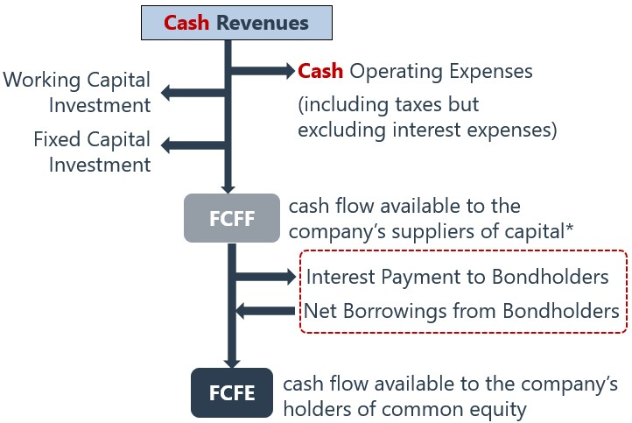

**The Choice of using FCFF or FCFE**

**FCFE is easier and more straightforward to use in cases where the company’s capital structure is not particularly volatile. If a company has negative FCFE and significant debt outstanding, FCFF is generally, the best choice**

**Analysts should use a free cash flow to equity valuation whenever dividends differ significantly from the company's capacity to pay dividends or when a change of control is anticipated.**

**A FCFF valuation is preferred over a FCFE valuation whenever the capital structure is unstable or ever-changing.**

$$Equity Value=Firm Value-Market Value of Debt$$

$$Firm Value=\frac{FCFF_{1}}{WACC-g}=\frac{FCFF_{0}\left(1+g\right)}{WACC-g}$$

**Free Cash Flow to Firm (FCFF) Valuation**

$$FCFF=NI+NCC+Int\left(1-t\right)-FC_{Inv}-WC_{Inv}$$

$$FCFF=CFO+Int\left(1-t\right)-FCInv$$

$$FCFF=EBIT\left(1 – t\right)+Dep-FC_{Inv}-WC_{Inv}$$

$$FCFF=EBITDA\left(1 – t\right)+ Dep×t-FC_{Inv}-WC_{Inv}$$

**Free Cash Flow to Equity (FCFE) Valuation**

$$FCFE=FCFF-Int\left(1-t\right)+Net Borrowing$$

$$FCFE=EBIT× (1-T) – Int×(1-T) + Dep – WCINV – FCINV +Net Borrowing$$

$$FCFE=EBITDA×(1-T) – Int×(1-T)+Dep×T – WCINV – FCINV +Net Borrowing$$

$$FCFE = NI + NCC – FCInv – WCInv + Net borrowing$$

$$FCFE = CFO – FCInv + Net borrowing$$

**Working capital for cash flow and valuation purposes is defined to exclude cash and short-term debt.**

* **Excluding cash, cash equivalents. A change in cash is what we are trying to explain.**
* **Excluding notes payable, and current portion of long-term debt. They are liabilities with explicit interest costs that make them financing items rather than operating items.**

$$WC=\left(Current Asset-Cash\right)-(Current Liability-Debt)$$

$$WC_{Inv}=WC_{t}-WC_{t-1}$$

$$FC_{Inv}=CapEx-Proceeds from Selling Long Term Assets$$

**NCC (Non-cash charges) adjustments for FCFF**

|  |  |
| --- | --- |
| **Noncash Item** | **Adjustment to NI to Arrive at FCFF** |
| Depreciation | Added back |
| Amortization and impairment of intangibles | Added back |
| Restructuring charges (expense) | Added back |
| Restructuring charges (income resulting from reversal) | Subtracted |
| Losses | Added back |
| Gains | Subtracted |
| Amortization of long-term bond discounts | Added back |
| Amortization of long-term bond premiums | Subtracted |
| Deferred taxes | Added back but calls for special attention |

**Remark:**

## 6.4 Residual Income Model

When cash flows are negative in the analyst’s comfortable forecast time horizon, the RI model is most appropriate. **Residual income is sometimes called economic profit because it estimates the company’s profit after deducting the cost of all capital. The RI model is less sensitive to estimates of terminal value than discounted dividend or cash flow models.**

$$\$WACC=WACC×Capital$$

$$EVA=NOPAT-\$WACC$$

$$V_{0}=B_{0}+\frac{\left(ROE-r\right)B_{0}}{r-g}$$

$$Book Value=\frac{Equity}{Shares Outstanding}$$

$$NOPAT=EBIT(1-t)$$

**It is difficult for a company to maintain a high ROE because of competition. The persistence factor will be lower for those companies. A company that has a low dividend payout has greater growth opportunities than a company with a high dividend payout. The greater growth opportunities should support a higher persistence factor.**

**Dupont Analysis**

$$ROE=\frac{NI}{Sales}×\frac{Sales}{Assets}×\frac{Assets}{Equity}$$

$$ROE=(Net Profit Margin)×(Asset Trunover)×(Equity Multiplier)$$

**PRAT model**

$$g=Retention Ratio×Profit Margin×Asset Turnover×Leverage$$

**EBITDA is a pre-interest earnings figure, in contrast to earnings per share, which is a post-interest figure. Thus the differences in financial leverage do not affect EBITDA.**

**EBITDA overestimates cash flow from operations if working capital is growing. Therefore, only Statement 1 is correct.**

# 7 Fixed Income

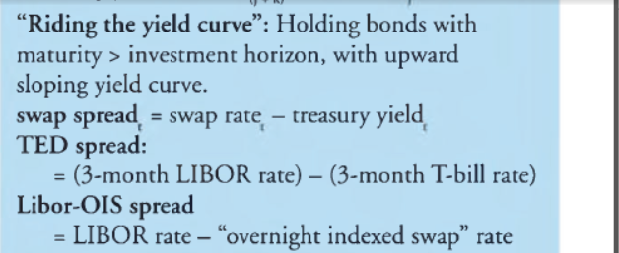

TED Spread = 3-month LIBOR - 3-month T-bill Rate

Libor-OIS Spread = LIBOR – Overnight Indexed Swap Rate

When the spot curve is upward sloping, the forward curve will lie above the spot curve.

When the spot curve is downward sloping, the forward curve will lie below the spot curve.

Remark: This relationship is a reflection of the basic mathematical truth that when the average is rising (falling), the marginal data point must be above (below) the average. In this case, the spot curve represents an average over a whole time period and the forward rates represent the marginal changes between future time periods.

**Riding the yield curve**: Holding bonds with maturity > investment horizon, with upward sloping yield curve.

If the yield curve is upward sloping and is expected not to change, then buying bonds with a maturity longer than the

investment horizon would provide a total return greater than the return on a maturity-matching strategy.

**Yield and spread (Cont.)**

$$Swap Spread = Swap Rate – Treasury Yield$$

Z-spread: is the constant basis point spread that would need to be added to the implied spot yield curve so that the discounted cash flows of a bond are equal to its current market price.

$$P = \frac{CF_{1}}{(1+r+Z)}+\frac{CF_{2}}{{\left(1+r+Z\right)}^{2}}+…$$

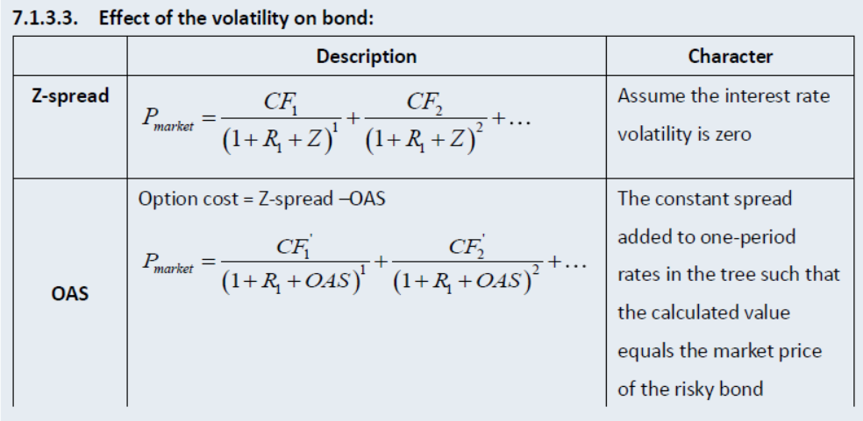

$$P = \frac{CF_{1}}{(1+r+OAS)}+\frac{CF_{2}}{{\left(1+r+OAS\right)}^{2}}+…$$

$$OAS = Z spread - Option Cost (\%)$$

*OAS = z-spread - option cost (call) OAS = z-spread + option cost (put)*

OAS is the value of the security WITHOUT the option, so option volatility should not impact OAS value.

**Remark: OAS和callable, putable 变化相同**

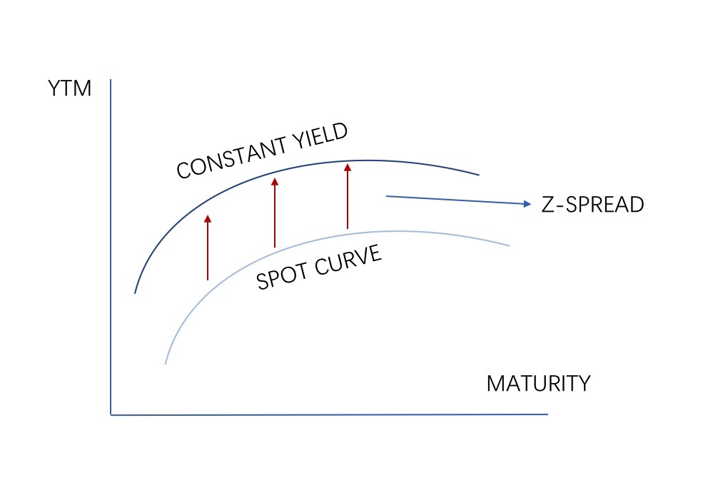

✓ Parallel shift of spot curve

✓ PV of bond cash flows equal to its market price

* TED spread = Libor – T-bill rate
* Libor-OIS spread = Libor – OIS rate

## 7.1 Term structure of interest rates

**Traditional theories of term structure**

**Pure expectations theory**

$$Forward Rate = Future Spot Rate$$

**Local expectations Theory**

**In the short term, $Forward Rate = Future Spot Rate$**

**Liquidity preference theory**

$$Forward Rate = Expected Spot Rate + Liquidity Premium$$

* **Liquidity premium increase with maturity**
* **Forward rates are a biased estimate of the market’s expectation of future rates because they include a liquidity premium.**

**Segmented market theory**

* **Yield for each maturity sector is determined by supply of and demand for loan, and independent from other sectors.**

**Preferred habitat theory**

* **If the premium is large enough, investor will deviate from their preferred maturities.**

**Equilibrium term structure models**

* **CIR Model (The Cox-Ingersoll-Ross model)**
$$dr_{t}= a\left(μ-r_{t}\right)dt + σ\sqrt{r_{t}}dW_{t}$$

* **Vasicek Model**

$$dr_{t}= a\left(μ-r_{t}\right)dt + σdW_{t}$$

**Arbitrage free Models**

* **Ho-Lee Model**

$$dr_{t}=θ_{t}dt + σdW_{t}$$

Effective duration

Key rate duration: bond price sensitivity to yield a specific maturity segment.

Key rate duration: shifting any par has an effect on the value of bond

Key rate durations or partial durations capture the interest rate sensitivity of a bond to changes in yields (par rates) of specific benchmark maturities.

Key Rate duration是衡量债券价格的变动相对于yield curve上某个点rate的移动。这样我们就彻底摆脱了curve整体平移的假设。

A bond’s sensitivity to changes in the shape of the yield curve, steepening or flattening, is captured by key rate duration. One-sided duration (up or down) is better than effective or two-sided duration at capturing the interest rate sensitivity of a callable or putable bond but only for a parallel shift in the yield curve, not for changes in the shape of the yield curve.

## 7.2 Bonds with Embedded Option

Puttable bonds

* Extendible bond
* Estate put

Sinking fund bonds (sinkers)

$$V_{callable} = V_{straight}-V_{call}$$

$$V_{puttable} = V_{straight}+V_{put}$$

* As interest rate volatility **increases**, the value of **callable** bond **decreases**; and vice versa.
* As interest rate volatility **increases**, the value of the **puttable** bond **increases**; and vice versa.
* As interest rates **decline**, the value of **callable** bond rises but less rapidly than straight bond.
* As interest rates **rise**, the value of **puttable** bond falls but less rapidly than straight bond.

Call rule: the value of callable bond is the lower of the call price and the calculated price if the bond is not called.

Put rule: the value of puttable bond is the higher of the put price and the calculated price if the bond is not put.

$$P = \frac{CF_{1}}{(1+r+OAS)}+\frac{CF_{2}}{{\left(1+r+OAS\right)}^{2}}+…$$

$$OAS = Z spread - Option Cost (\%)$$

|  |  |  |  |
| --- | --- | --- | --- |
|  | Option Cost | OAS | Effective Convexity |
| Callable Bond | > 0 | OAS < Z-spread | turn negative when in-the-money |
| Puttable Bond | < 0 | OAS > Z-spread | turn higher when in-the-money |
| Straight bond | = 0 | OAS = Z-spread | + |

*OAS = z-spread - option cost (call) OAS = z-spread + option cost (put)*

The option-adjusted spread (OAS) is the constant spread that is added to all one-period forward rates on the interest rate tree and results in the present value of the bond’s cash flows, or arbitrage-free value, equaling the bond’s market price.

For two bonds that have otherwise similar characteristics, the bond with the higher OAS is underpriced, or, alternatively, the bond with the lower OAS is overpriced.

* Lower OAS → overpriced; higher OAS → underpriced
* As interest rate volatility increases, the OAS for the callable bond decreases, and vice versa.
* As interest rate volatility increases, the OAS for the puttable bond increases, and vice versa.

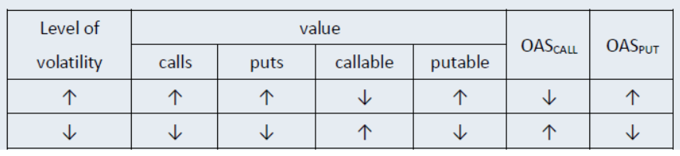

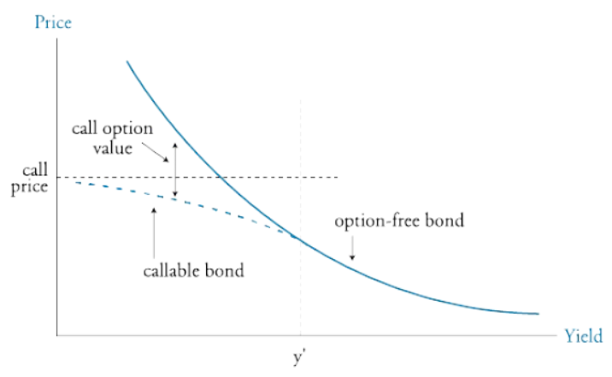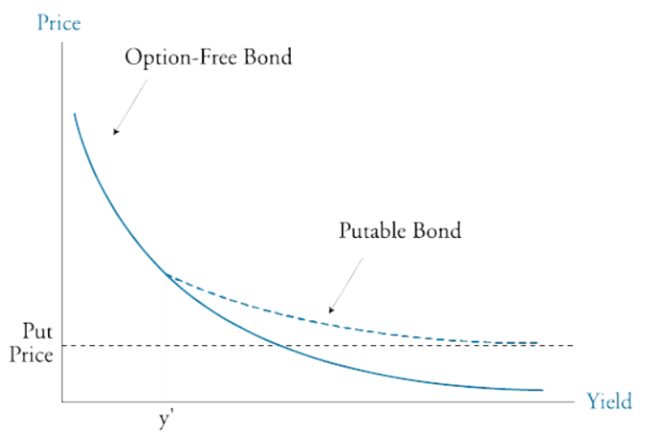

**Effective Duration and Effective Convexity**

* Modified duration, can be used only for option-free bonds because these measures assume that a bond’s expected cash flows do not change when the yield changes.
* The values of embedded options are typically contingent on interest rates. Thus, for bonds with embedded options, the only appropriate duration measure is the curve duration measure known as effective (or option-adjusted) duration.
* Effective convexity is a discrete approximation of the second derivative of the bond's value as a function of the interest rate

$$ED= \frac{V_{-Δy}-V_{+Δy}}{2Δy⋅V_{0}}$$

$$EC = \frac{V_{-Δy}+V_{+Δy}-2V_{0}}{Δy^{2}⋅V_{0}}$$

Effective convexity

* Straight bond: always positive
* Callable bond: turn negative when in-the-money
* Puttable bond: turn higher when in-the-money

Remark: It is easy to understand if you look at the figures.

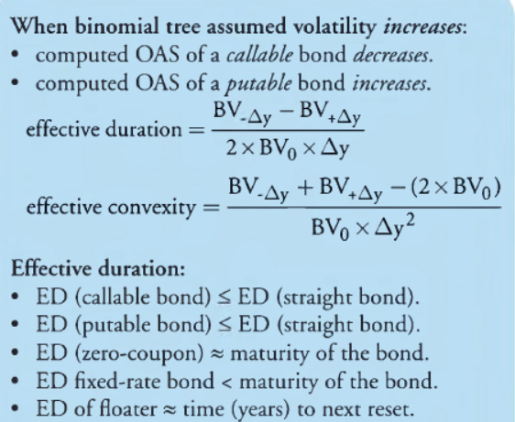

$$ED_{callable}≤ED_{straight}$$

$$ED_{puttable}≤ED_{straight}$$

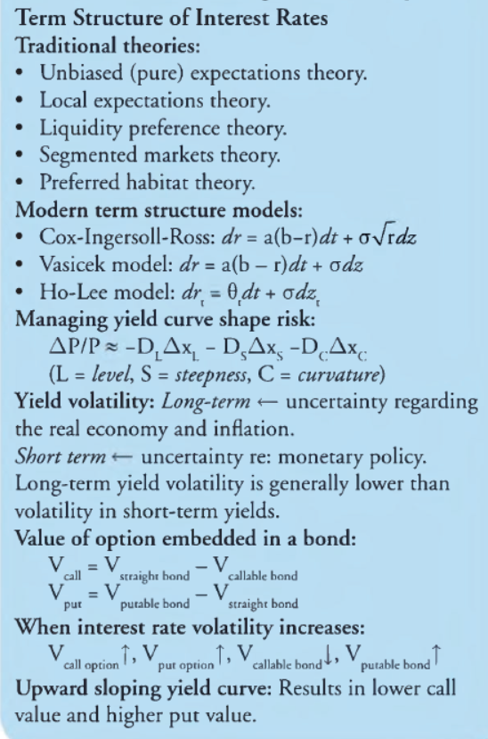

## 7.3 Credit Analysis Models

$$Expected Loss=Default Probability×Loss Given Default$$

Credit valuation adjustment (CVA) is the value of the credit risk in present value term. (The sum of PV of expected loss)

$$Fair Value of Corporate Bond=VND-CVA$$

**VND: the value for the corporate bond assuming no default**

**Credit Transition Matrix**

➢ Credit spread migration typically reduces the expected return for two reasons.

■ First, the probabilities for change are not symmetrically distributed around the current rating. They are skewed toward a downgrade rather than an upgrade.

Second, the increase in the credit spread is much larger for downgrades than the decrease in the spread for upgrades.

**Structural Model**

Holding the company’s equity is economically equivalent to owning a European call option on the company’s asset.

Owning the company’s debt is economically equivalent to owning a risk­less bond that pays with certainty at time T, and simultaneously selling a European put option on the assets of the company with strike price K and maturity T.

$$Value of risky debt = value of risk-free debt – value of a put option$$

Structural models require that the company's assets trade in a frictionless arbitrage free market.

**The relevant assumption is that the value of the assets (at maturity) has a lognormal distribution.**

**Reduced Form Model**

Do not explain why default occurs, but statistically model when default occurs.

Ratings tend to be stable over time, which reduces their correlation to default probabilities

## 7.4 CDS

$$Hazard Rate = Conditional Probability of Default$$

$$Expected Loss_{t}=Hazard Rate_{t}×LGD$$

Upfront premium on a CDS

(loss given default)t

Up fount payment (paid by protection buyer) = PV(Protection leg)- PV(Premium leg) or approximately: Up fount premium % (paid by protection buyer) ≈ (CDS spread-CDS coupon) x duration

# 8 Derivatives

## 8.1 Forward

**Equity forward with discrete dividends**

$$F_{0}\left(T\right)=\left(S_{0}-PVD_{0}\right)×{\left(1+r\right)}^{T}=S_{0}×{\left(1+r\right)}^{T}-FVD_{T}$$

**Fixed income forward with discrete coupon**

$$F_{0}\left(T\right)=\left(S_{0}-PVC_{0}\right)×{\left(1+r\right)}^{T}=S_{0}×{\left(1+r\right)}^{T}-FVC_{T}$$

Remark: Equity forward and Fixed income forward are in some sense the same.

**Equity index forward with continuous dividend**

## 8.2 Swap

PVFixed rate bond = PVFloating rate bond = Par value

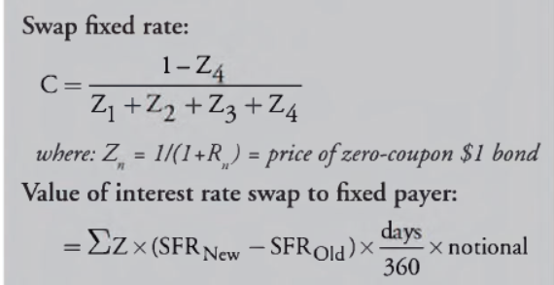

$$1=Swap Rate×\left(D_{1}+D_{2}+…+D_{n}\right)+1×D_{n}$$

$$Swap Rate=\frac{1-D_{n}}{D_{1}+D_{2}+…+D_{n} }$$

$$D_{n}=\frac{1}{1+R_{n}}$$

$D_{n}$ is discount factor or PV factor, the present value of $\$1$ in $n$ periods.

Remark: $The annualized fixed rate of the swap = n×Swap Rate$

**Valuation of swap**

**Interest Rate Swap**

For fixed-rate receiver (floating-rate payer):

$$V_{t}=NP(PV_{Fixed}– PV_{Floating})$$

For fixed-rate payer (floating-rate receiver):

$$V_{t}=NP(PV_{Floating}-PV_{Fixed})$$

**Note**: the value of a floating rate payment will be equal to the par value at each settlement date.

**Equity Swap**

$$V_{t}= PV_{Fixed} – NP×\frac{S_{t}}{S_{0}}$$

$$V_{t}= PV_{Floating}-NP×\frac{S_{t}}{S_{0}}$$

$$V_{t} = NP×\frac{S_{t}}{S_{0}}– NP×\frac{S_{t}^{'}}{S_{0}}$$

There are different types of equity swaps

* pay fixed rate and receive equity return
* pay floating rate and receive equity return
* pay one equity return and receive another equity return

## 8.3 Future

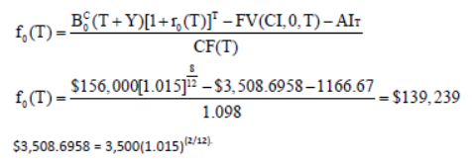

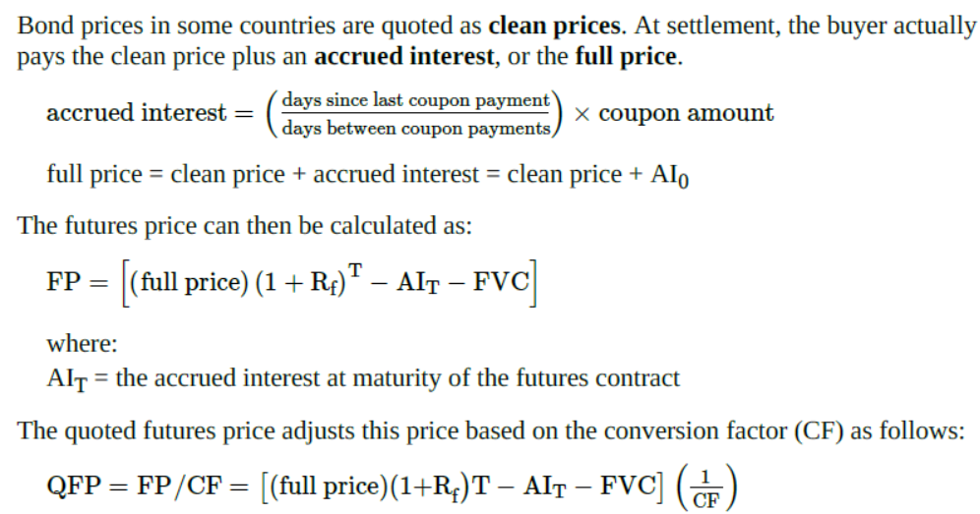

Bond prices in some countries are quoted as clean prices. At settlement, the buyer actually pays the clean price plus an accrued interest, or the full price.

$$accrued interest = ( \frac{days since last coupon payment}{days between coupon payments}) × coupon amount$$

$$Full Price = Clean Price + Accrued Interest=Clean Price+AI_{0}$$

$$Future Price = [\left(Full Price\right){\left(1 + r\right)}^{T}-AI_{T}-FVC]$$

where:

$AI_{T}$ is the accrued interest at maturity of the futures contract

The quoted futures price adjusts this price based on the conversion factor (CF) as follows:

$$QFP =\frac{Future Price}{CF}= \frac{(Full Price) {\left(1+r\right)}^{T}-AI_{T}-FVC}{CF}$$

$$QFP =\frac{Future Price}{CF}= \frac{(S_{0}+AI_{0}) {\left(1+r\right)}^{T}-AI_{T}-FVC}{CF}$$

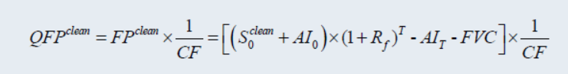

## 8.4 Option

$$p=\frac{1+r-d}{u-d}$$

$$q=1-p=\frac{u-(1+r)}{u-d}$$

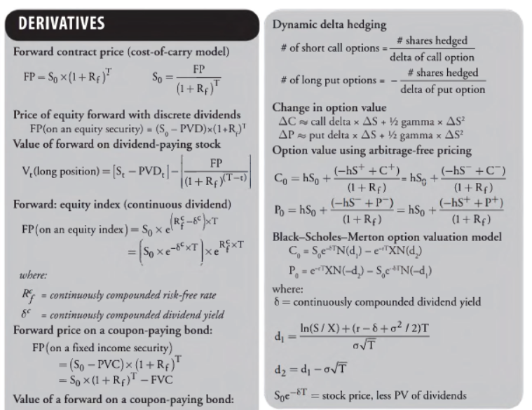

**Binomial valuation model for interest rate option**

* The valuation of interest rate option is similar to that of

stock option, except that the payoff at maturity is different:

✓Call payoff = Max(0, underlying rate – exercise rate)×NP

✓Put payoff = Max(0, exercise rate – underlying rate)×NP

* + Note: we must use **binomial interest rate tree model** for valuation of interest rate option.

**Delta hedging**

$$N_{call}=\frac{N_{stock}}{Δ} N_{put}=-\frac{N_{stock}}{Δ}$$

$$ΔV= Delta×ΔS+\frac{1}{2}Gamma×ΔS^{2}$$

Delta-neutral portfolio: the portfolio value does not change with variation of the underlying asset price.

Long stocks, short call options;

Long stocks, long put options;

Long call options, long put options.

**Black-Scholes-Merton Model**

$$C=S_{0}e^{-δT}N\left(d_{1}\right)-{Ke}^{-rT}N(d_{2})$$

$$P={Ke}^{-rT}N\left(-d_{2}\right)-S_{0}e^{-δT}N(-d_{1})$$

$$d_{1}=\frac{ln⁡({S_{0}}/{K)+(r-δ+{σ^{2}}/{2)T}}}{σ\sqrt{T}}=\frac{\ln{{(S}_{0}e^{-δT}}/Ke^{-rT})}{σ\sqrt{T}}+\frac{σ\sqrt{T}}{2}$$

$$d_{2}=\frac{ln⁡({S_{0}}/{K)+(r-δ-{σ^{2}}/{2)T}}}{σ\sqrt{T}}=\frac{\ln{{(S}_{0}e^{-δT}}/Ke^{-rT})}{σ\sqrt{T}}-\frac{σ\sqrt{T}}{2}$$

$$d_{2}=d_{1}-σ\sqrt{T}$$

$$S_{0}e^{-δT}=stock price-PV_{dividend}$$

Remark: For dividend, replace $S_{0}$ with $S_{0}e^{-δT}$

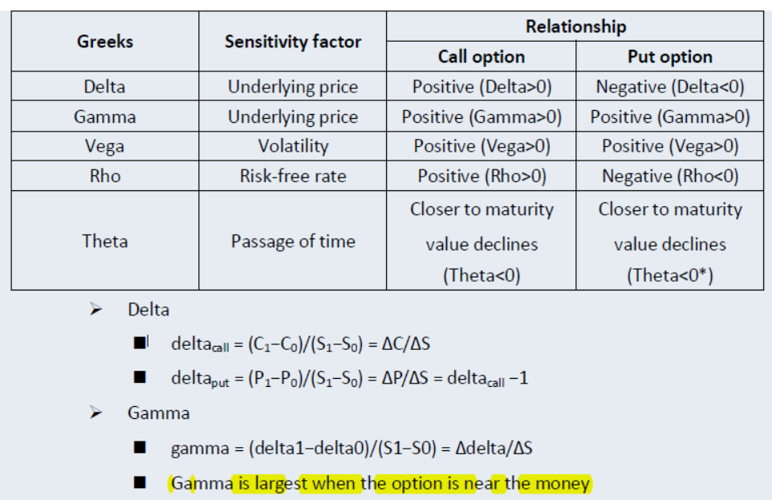

|  |  |  |
| --- | --- | --- |
| Variable | Call | Put |
| Delta | $$+$$ | $$-$$ |
| Gamma | $$+$$ | $$+$$ |
| Vega | $$+$$ | $$+$$ |
| Rho | $$+$$ | $$-$$ |
| Theta |  |  |
|  |  |  |

**Gamma**

* Gamma for a call and put option with identical features are the same, and both are positive;
* Gamma is largest when the option is at-the-money;
* If the option is deep in- or out-of-the-money, gamma approaches zero.
* **Gamma risk: stock prices jump rather than move continuously and smoothly.**

**Theta**

* Theta is usually negative for both call and put option; With excerption to deep in-the-money put option.

**Vega**

* Vega for call option is equal to Vega for put option with identical features, and both are positive;
* **Vega is high when options are at or near the money.**

**Interest Rate Option**

$$Payoff_{Call}=max\left(Reference Rate-Exercise Rate, 0\right)×Notional Principal$$

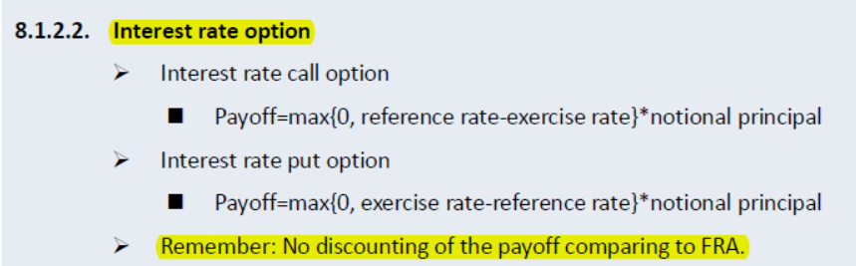

**A combination of the purchase of an interest rate call option and the sale of an interest rate put option is equivalent to a plain vanilla interest rate swap payment.**

## 8.5 Derivatives Strategies

**Interest rate swap**

* Fixed-rate receiver: increase duration;
* Fixed-rate payer: decrease duration.

**Interest rate futures**

* Long interest rate futures: increase duration;
* Short interest rate futures: decrease duration.

**Stock index futures**

* Long stock index futures: increase the equity exposure;
* Short stock index futures: decrease the equity exposure.

**Synthetic asset with options**

* Long asset = long call + short put (S = C – P)
* Short asset = short call + long put (-S = -C + P)

**Synthetic options**

* Long call = long asset + long put (C = S + P)
* Long put = Short asset + long call (P = -S + C)

**Synthetic asset with forward/futures**

Long asset = long futures + risk-free asset (cash)

**Covered call (S - C)**

* Investment objectives:
  + Income generation
  + Improving on the market
  + Target price realization
* **Risk** of covered call:
  + Keeps the downside risk of the stock position;
  + Gives up the upside potential of the stock position.

**Protective put (S + P)**

* **Investment objectives**:
  + Provide protection or insurance against a price decline.
* **Risk** of protective put:
  + The put premium will reduce the portfolio return.

**Covered call vs. (long asset + short forward)**

* **From the aspect of delta, a covered call position is equivalent to a position of (long a stock + short forward for detalcall unit).**
  + **Both of them have delta of (1- deltacall).**

**Protective put vs. (long asset + short forward)**

* **From the aspect of delta, a protective put position is equivalent to a position of (long a stock + short forward for detalput unit).**
  + **Both of them have delta of (1+ deltaput).**

**Spread strategy**

* **Bull spread: long an option and short another with a higher exercise price;**
  + **Bull call spread**
  + **Bull put spread**
* **Bear spread: long an option and short another with a lower exercise price;**
  + **Bear call spread**
  + **Bear put spread**

**Collar**

* **Structure: long put + short call + underlying asset**
* **Investment objective: buy a protective put and sell a call to offset the premium.**
  + **Zero-cost collar: the premiums for call and put are equal.**

**Straddle**

* **Long straddle: Long call + long put, with the same exercise price, on the same underlying asset.**
  + **Long volatility.**

**Choice of derivative strategies**

* For expectation of market direction, typically:
  + Long call/put: strong bullish/bearish expectation;
  + Long call + short put: average bullish expectation;
  + Short call + long put: average bearish expectation;
  + Writing call/put: weak bearish/bullish expectation.
* For expectation of volatility, typically:
  + Long straddle: high volatility expectation;
  + Short straddle: low volatility expectation.

# 9 Alternative Investments

## 9.1 Value of Property Using Direct Capitalization

$$NOI= Rental Income at Full Occupancy+Other Income (PGI)$$

$$-Vacancy and Collection Loss \left(EGI\right)$$

$$-Operating Expenses$$

$NOI$: Net Operating Income

$PGI$: Potential Gross Income

$EGI$: Effective Gross Income

$$Cap Rate=\frac{NOI_{1}}{Comparable Sales Price}$$

$$V_{0}=\frac{NOI_{1}}{Cap Rate}$$

$$Cap Rate = Discount Rate-Growth Rate=r-g$$

$$TV_{5}=\frac{NOI_{5}\left(1+g\right)}{C_{t}}$$

The capitalization rate (also known as cap rate) is used in the world of commercial real estate to indicate the rate of return that is expected to be generated on a real estate investment property. This measure is computed based on the net income which the property is expected to generate and is calculated by dividing net operating income by property asset value and is expressed as a percentage**. It is used to estimate the investor's potential return on their investment in the real estate market.**

**Debt service coverage ratio**

$$DSCR=\frac{NOI_{first-year}}{Debt Service}$$

$$Loan=\frac{Debt Service}{Interest Rate}$$

Debt service is the cash that is required to cover the repayment of interest and principal on a debt for a particular period.

**Loan-to-value (LTV) ratio**

$$LTV=\frac{Loan Amount}{Appraisal Value}$$

The maximum amount of debt can obtain on commercial real estate is limited by LTV and DSCR, depending on which measure results in the lowest loan amount.

**Cost approach** considers what it would cost to buy the land and construct a new property on the site that has the same utility or functionality as the property being appraised (referred to as the subject property).

**Sales comparison approach** considers what similar or comparable properties(comparables) transacted for in the current market.

## 9.2 REITs share valuation

**Investment in both public REOCs and public REITs enjoy high liquidity, as shares of both trade on a stock exchange. Tax advantages favor REITs as REOCs are not tax- advantaged. REOCs are more reliant on capital appreciation due to their ability to reinvest cash flows, while REITs tend to have higher current income (i.e., yield).**

Tax advantages can be enjoyed by direct investments in real estate, as well as through public securities. Similarly, use of leverage can be pursued by all three options.

Real estate returns generally have low correlations with returns on other assets classes, such as stocks and bonds, and thus allow the endowment to diversify portfolio risk.

$$TV_{5}=\frac{NOI_{5}\left(1+g\right)}{C_{t}}$$

$$Estimated property value$$

$$= Market Value of land + Replacement building costs$$

$$– Curable physical depreciation costs$$

$$– Incurable physical depreciations costs$$

$$– Cost of modernizing heating and cooling system.$$

|  |  |
| --- | --- |
| Market value (MV) of land | $2,500,000 |
| Replacement building costs | $20,000,000 |
| Curable physical depreciation costs | $500,000 |
| Incurable physical depreciation costs | $3,500,000 |
| Cost of modernizing heating and cooling system | $1,200,000 |
| Estimated property value | $17,300,000 |

## 9.3 Private Equity Valuation

Economic terms of a PE fund

* **Carried interes**t represents the general partner’s share of profits generated by a private equity fund. Carried interest is frequently in the region of 20% of the fund’s profits (after management fees).
* **Ratchet (棘轮条款)** is a mechanism that determines the allocation of equity between shareholders and the management team of the private equity controlled company. A ratchet enables the management team to increase its equity allocation depending on the company’s actual performance and the return achieved by the private equity firm.
* **Hurdle rate (最低资本回报率)** is the internal rate of return that a private equity fund must achieve before the GP receives any carried interest.
* Target fund size: A fund that closed with a significantly lower size relative to the target size would raise questions about the GP’s ability to raise funds on the market and would be perceived as a negative signal.
* **Vintage year** is the year the private equity fund was launched.
* Term of the fund is typically 10 years, extendable for additional shorter periods.

**Corporate governance terms**

* **Key man clause (关键人条款)**: a certain number of key named executives are expected to play an active role in the management of the fund.
* Disclosure and confidentiality: Private equity firms have no obligations to disclose publicly their financial performance.
* **Clawback provision (回拨机制条款)**: A clawback provision requires the GP to return capital to LPs in excess of the agreed profit split between the GP and LPs.
* **Distribution waterfall**: A distribution waterfall is a mechanism providing an order of distributions to LPs first before the GP receives carried interest. Two distribution mechanisms are deal-by-deal waterfalls and total return waterfalls.
* **Tag-along**, **drag-along rights** are contractual provisions in share purchase agreements that ensure any potential future acquirer of the company may not acquire control without extending an acquisition offer to all shareholders, including the management of the company.
* **No-fault divorce** is that a GP may be removed without cause, provided that a super majority (generally above 75 percent) of LPs approve that removal.
* **Removal for cause** is a clause that allows either a removal of the GP or an earlier termination of the fund for “cause.”
* **Investment restrictions** generally impose a minimum level of diversification of the fund’s investments, a geographic and/or sector focus, or limits on borrowing.
* **Co-investment**: LPs generally have a first right of co-investing along with the GP. This can be advantageous for the LPs as fees and profit share are likely to be lower (or zero) on co-invested capital. The GP and affiliated parties are also typically restricted in their co-investments to prevent conflicts of interest with their LPs.

A capital call, also known as a "draw down," is the act of collecting funds from limited partners whenever the need arises. When an investor buys into a private equity fund, the firm makes an agreement with the investor that these funds will be available when the firm requests them.

DPI (distributed to paid in) is the cumulative distributions paid out to LPs as a proportion of the cumulative invested capital.

$$DPI=\frac{Total distributions}{Total call downs}$$

PIC (Paid-in capital/committed capital, OR $ utilized by GP)

DPI (distributedto paid-in capital)

RVPI (residualvalue to paid-in capital)

TVPI (total valueto paid-in capital)

The carried interest is calculated as 20% times the increase in net asset value (NAV) before distributions. Note that for carried interest to apply, NAV before distribution must exceed committed capital.

The £300 million fund has a vintage of 2011, which is committed capital, management fees of 2%, carried interest of 20%, a hurdle rate of 7%

|  |  |  |  |  |  |  |
| --- | --- | --- | --- | --- | --- | --- |
| **Exhibit 1 YCP UK VI—Operating Results (£ millions) as of 31 Dec. 2016** | | | | | | |
|  | **2011** | **2012** | **2013** | **2014** | **2015** | **2016** |
| **Called Down** | 120 | 40 | 25 | 60 | 25 | 10 |
| Realized Results | 0 | 0 | 25 | 80 | 100 | 195 |
| Unrealized Results | -15 | -35 | 35 | 25 | 35 | 60 |
| Distributions |  |  |  | 60 | 110 | 175 |

|  |  |  |  |  |  |  |  |  |
| --- | --- | --- | --- | --- | --- | --- | --- | --- |
|  | **Called Down** | **PIC** | **Mgmt. Fee** | **Operating Results** | **NAV** | **Carried Interest** | **Distribution** | **NAV Post-Dist.** |
| 2011 | 120 | 120 | 2.4 | –15 | 102.6 |  |  | 102.6 |
| 2012 | 40 | 160 | 3.2 | –35 | 104.4 |  |  | 104.4 |
| 2013 | 25 | 185 | 3.7 | 60 | 185.7 |  |  | 185.7 |
| 2014 | 60 | 245 | 4.9 | 105 | 345.8 | **9.16** | 60 | 276.64 |
| 2015 | 25 | 270 | 5.4 | 135 | 431.24 | 17.088 | 110 | 304.152 |
| 2016 | 10 | 280 | 5.6 | 255 | 563.552 | 26.462 | 175 | 362.09 |

## 9.4 Commodities

**Contango**: $futures prices > spot prices$

* Have a negative calendar spread
* negative roll return

**Backwardation**: $futures prices < spot prices$

* Have a positive calendar spread.
* Occurs when hedgers (producers) are short in the futures contract.
* positive roll return

**Considering the storage theory, non-storable commodities are characterized by a high percentage of backwardation, while commodities with low storage costs, such as precious metals, are almost exclusively in contango.**

**Convenience yield** is the monetary benefit from holding a commodity physically instead of being long the respective futures, and is affected in large part by inventory levels.

$$Total Return = Price return + Roll return + Collateral return$$

**Collateral return**: the yield for the bonds or cash used to maintain the investor’s futures positions.

**Roll Return**: return from closing out maturing futures contracts and replacing them with newer futures contracts.

When the commodity’s term structure is in backwardation, positive roll return because long-dated contracts are cheaper than expiring contracts. When the commodity’s term structure is in contango, negative roll return.

**Term Structure of Commodity Futures**

**Insurance Theory**: Contract buyers compensated for providing protection to commodity producers. Implies backwardation is normal.

**Hedging Pressure Hypothesis**: Like insurance theory, bur includes both long hedgers (lead to contango) and short hedgers (lead to backwardation).

* If the two forces of producers and consumers both seeking price protection are equal in weight, then then commodity curve will be flat.
* If commodity producers as a group are more interested in selling forward than consumers, then the commodity curve will be backwardation.
* If commodity consumers exceed producers, then the commodity curve will be contango.

**Theory of Storage**: Spot and futures prices related through storage costs and convenience yield.

* A commodity regularly stored should have a higher price in the future (contango) to account for those storage costs, supply dominates demand.
* A commodity along a value chain that allows for just-in-time delivery and use (i.e., Minimal inventories and storage) can avoid these costs, demand dominates supply and current prices are higher than futures prices (i.e., Backwardation).

# 10 Portfolio Management

## 10.1 ETF

**Creation/redemption of ETFs**: Authorized participants (APs) create additional shares by delivering the creation basket to the ETF manager. Redemption is by tendering ETF shares and receiving a redemption basket.

**ETF spreads**: Positively related to cost of creation/redemption, spread on the underlying securities, risk-premium for carrying trades until close of trade, and APs' normal profit margin. Negatively related to probability of completing an offsetting trade on the secondary marker.

Some ETF legal structures expose investors to counterparty risk: the invested amount could be lost in the event of counterparty failure.

Settlement risk is applicable for ETFs that use OTC derivative contracts, however ADRs are exchange-traded.

**Break-even inflation rate (BEI)** : the yield difference between a non-inflation-indexed risk-free bond and the inflation- indexed risk-free bond with the same maturity.

$$BEI=Yield_{non-indexed}-Yield_{indexed}$$

$$BEI=Eπ+inflation risk premium$$

The breakeven inflation rate represents a measure of expected inflation derived from 10-Year Treasury Constant Maturity Securities (BC_10YEAR) and 10-Year Treasury Inflation-Indexed Constant Maturity Securities (TC_10YEAR). The latest value implies what market participants expect inflation to be in the next 10 years, on average.

## 10.2 Arbitrage Pricing Model

$$ER_{P}=r+Σ\left(Factor Sensitivity×Factor Risk Premium\right)=r+Σβ_{i}λ_{i}$$

* $λ_{i}$ = the expected risk premium for risk factor $i$; or the risk premium for a pure factor portfolio for factor $i$.
* CAPM can be regarded as a special case of APT with only one risk factor (market risk factor).
* If two portfolios with identical risk factors and factor sensitivities have different return, there is an arbitrage opportunity.

A portfolio that has a factor beta equal to one for one factor and factor betas equal to zero for all other factors is called a **factor portfolio**. In contrast, a portfolio that has factor betas equal to the benchmark factor betas is called a **tracking portfolio**. Unlike the tracking portfolio, the factor portfolio betas are not identical to the benchmark betas.

$$Active Return=Factor Return+Security Selection Return$$

$$Active return=\sum{\left[\left(Portfolio Sensitivity-Benchmark Sensitivity\right)×Factor Return\right]}+Security Selection Return$$

$$Active Return=Portfolio Return-Benchmark Return$$

$$Active Risk Squared=Active Factor Risk+Active Specific Risk$$

$$IR= \frac{R_{P}-R_{B}}{σ(R_{P}-R_{B})}=\frac{R_{A}}{σ_{A}}=\frac{Active Return}{Active Risk}$$

$$IR= TC×IC×\sqrt{BR}$$

* Information Coefficient (IC): a measure of manager’s forecasting accuracy. IC ranges from 0 to 1, with 0 denoting no linear relationship between predictions and actual values (poor forecasting skills) and 1 denoting a perfect linear relationship (good forecasting skills).
* Transfer Coefficient (TC): a measure of the degree to which the investor’s forecasts are translated into active weights.
  + Portfolios without any constraints, $TC = 1$;
  + Portfolios with constraints, $TC < 1$.
* Breadth (BR)
  + A measure of how much efforts the manager has put into.
  + Number of independent active decisions make per year.

**The Fundamental Law of Active Management**

$$E\left(R_{A}\right)= IR⋅σ_{A}=TC⋅IC⋅\sqrt{BR}⋅σ_{A}$$

**Optimal Level of Sharp Ratio**

$$Sharp Ratio= \sqrt{SR_{B}^{2}+IR_{P}^{2}}$$

* The portfolio with the highest information ratio will have the highest Sharpe ratio.

**Optimal Level of Active Risk**

$$σ_{A}= \frac{IR}{SR_{B}}σ_{B}$$

$$σ_{P}^{2}= σ_{A}^{2}{ + σ}_{B}^{2}$$

The optimal active risk for a constrained portfolio = TC ×optimal active risk for an unconstrained portfolio.

The optimal active risk for a constrained portfolio=TC *optimal active risk for an unconstrained portfolio. Given that TC < 1 for constrained portfolio, the optimal active risk for a constrained portfolio will be lower than the optimal active risk for an unconstrained portfolio.

|  |  |
| --- | --- |
| **Sharp Ratio** | **Information Ratio** |
| Total risk-adjusted value added | Relative risk adjusted value added |
| Unaffected by the addition of cash or use of leverage | Affected by the addition of cash or use of leverage |
| Affected by the aggressive active weight | Unaffected by the aggressive active weight |
| **Two ratios would be equal if the benchmark is risk-free asset** | |

Information ratio, unlike the Sharpe ratio, is affected by an allocation to cash or by the use of leverage. For an unconstrained optimization, a change in aggressiveness in active weights changes both the active return and active risk proportionally, leaving the information ratio unchanged.

The optimal active risk for a constrained portfolio=TC *optimal active risk for an unconstrained portfolio. Given that TC < 1 for constrained portfolio, the optimal active risk for a constrained portfolio will be lower than the optimal active risk for an unconstrained portfolio.

## 10.3 Value at Risk

**Value at Risk (VaR): Estimate of minimum loss with a given probability over a specified period, express as $ amount or % of portfolio value.**

**Conditional VaR(CVaR): The expected loss give that the loss exceeds the VaR.**

* Parametric method
$$VaR(X\%) = E(R) - ZX\%×σ$$

$$VaR(X\%) = E(R) - ZX\%×σ$$

$$VaR(X\%)dollar = [E(R) - ZX\%×σ]×asset value$$

$$5\% Annual \$VaR=\left(ER_{Annual}-1.65σ_{Annual}\right)×Portfolio Value$$

* Historical simulation method
* Monte Carlo simulation method

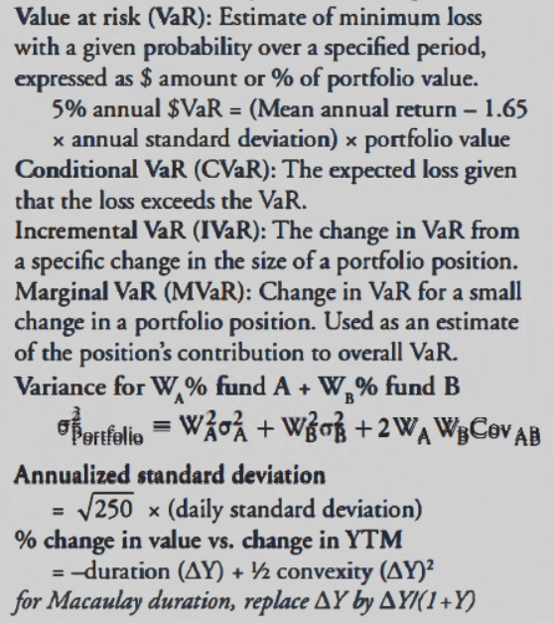

Maximum drawdown is most commonly defined as the worst peak-to-trough decline in a portfolio's returns, or the worst-returning month or quarter for a portfolio.

Remark: VaR大小逻辑上要看绝对值

$$σ_{annualized}=\sqrt{250} σ_{daily}$$

## 10.4 Inter-temporal rate of substitution (ITRS, $m_{t}$)

$$ITRS=m_{t}=\frac{U_{t}}{U_{0}}=\frac{U_{t}}{U_{0}}$$

$$r=\frac{1}{Em_{t}}-1 or \frac{1}{1+r}=\frac{U_{t}}{U_{0}}$$

$$P_{0}=\frac{EP_{1}}{1+r}+Cov(P_{1},m_{1})$$

$m_{t} < 1$ because $U_{0} > U_{t}$

$U_{t}$: marginal utility of consuming 1 unit in the future

$U_{0}$: marginal utility of consuming 1 unit today

$Cov\left(P_{1},m_{1}\right)<0$:

* The covariance between a risk-averse investor's intertemporal rate of substitution and expected future price is negative.
* The covariance between the expected future price of the bond and the investor’s intertemporal rate of substitution can be viewed as a risk premium.

For countries with high expected economic growth rates, real rates will be high. Investors will be less concerned about the future, and the inter-temporal rate of substitution will be low. Also, investors will want to increase current consumption and, hence, will borrow more and save less.

因为风险厌恶投资者不喜欢不确定性，所以需要补偿，价格不能卖的那么贵，需要扣减一块（加上一个negative cov）就可以了。

[**https://breakingdownfinance.com/finance-topics/finance-basics/intertemporal-rate-of-substitution/**](https://breakingdownfinance.com/finance-topics/finance-basics/intertemporal-rate-of-substitution/)

**Wash trading** is a kind of market manipulation where the investor buys and sells the same financial instrument simultaneously, in order to simulate demand in the instrument by boosting trading volume.

**Layering**: placing a legitimate trade on one side of the market and several bogus orders on the other side of the market. **quote stuffing**: entering large quantities of fictitious orders into the market and instantaneously canceling them.

$$effective spread for a buy order = 2 x (trade price -midquote)$$

$$effective spread for a sell order = 2 x (midquote -trade price)$$